create database car_sales_db;
use car_sales_db;
CREATE TABLE car_sales_raw (
Sale_ID INT,
Month VARCHAR(20),
Year INT,
Brand VARCHAR(50),
Car_Model VARCHAR(100),
City VARCHAR(50),
Region VARCHAR(50),
Units_Sold INT,
Avg_Price_Lakh DECIMAL(10,2),
Discount_Pct DECIMAL(5,2),
Revenue_Crore DECIMAL(10,2),
Dealer_ID VARCHAR(20)
);
Go to Table Data Import Wizard on the right click from this tables
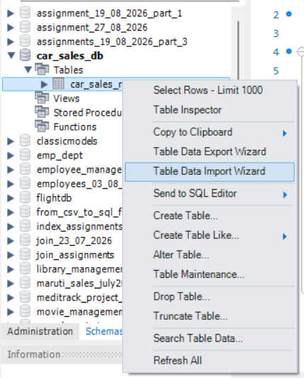

This is Table Data Import Wizard Dialog Window
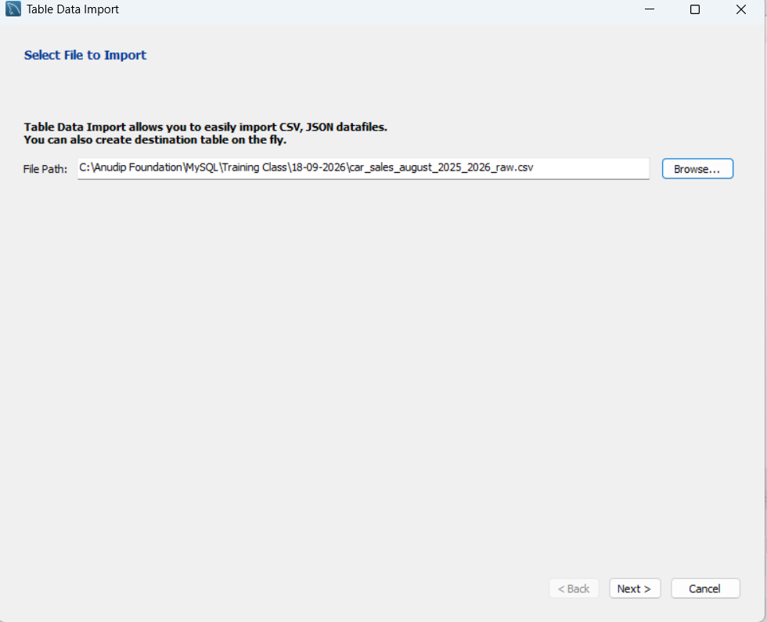

Click browse button and Select a CSV File
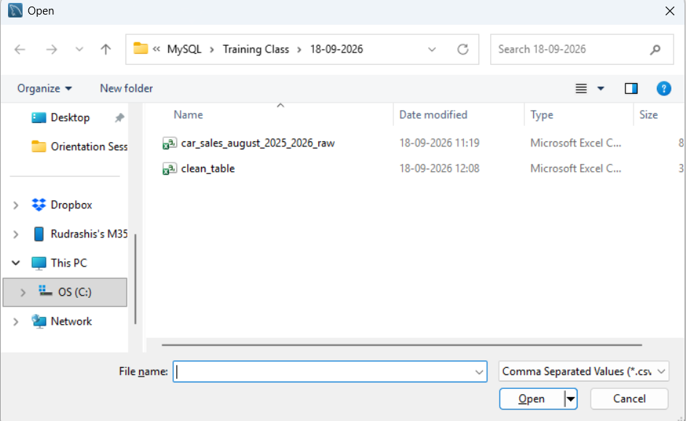
Select car_sales_august_2025_2026_raw.csv
Click Open

Then Click Next
Select Either Existing Table or Create a new table
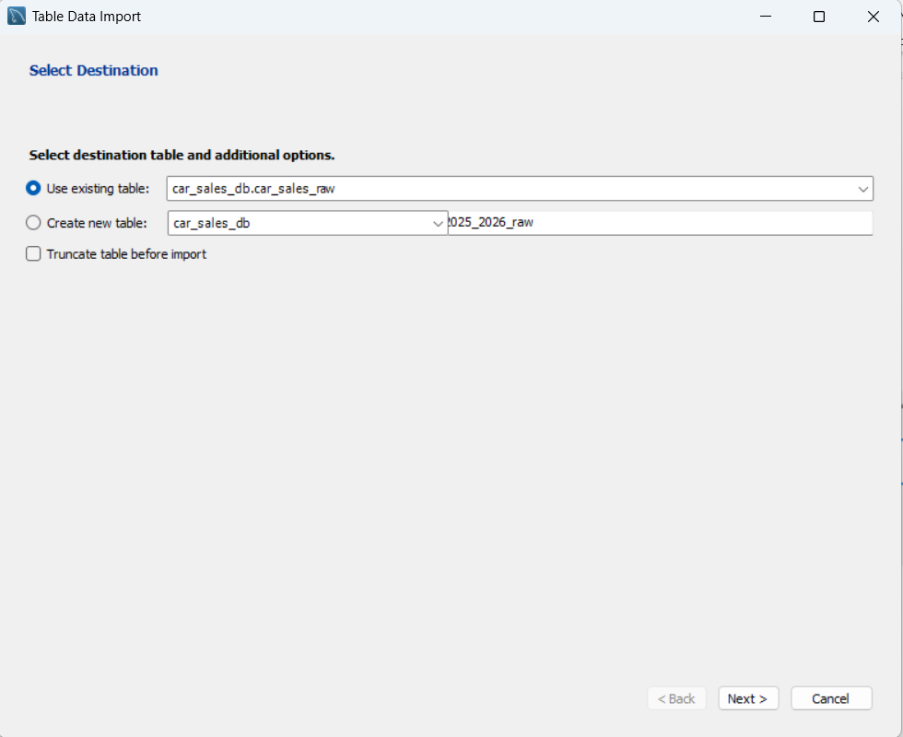
Click Next

Check the Configure
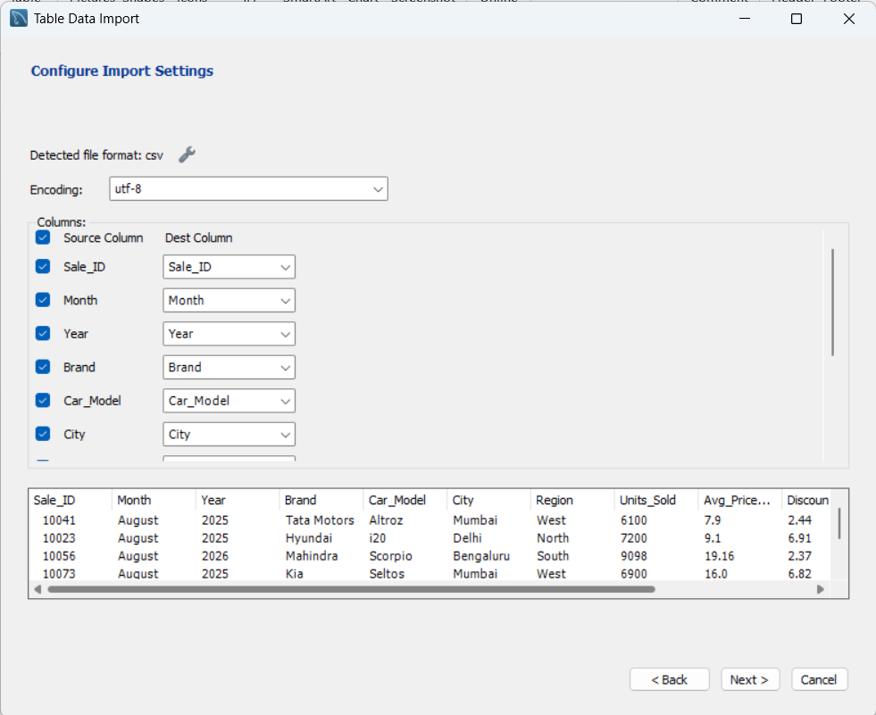

Prepare the Import Data
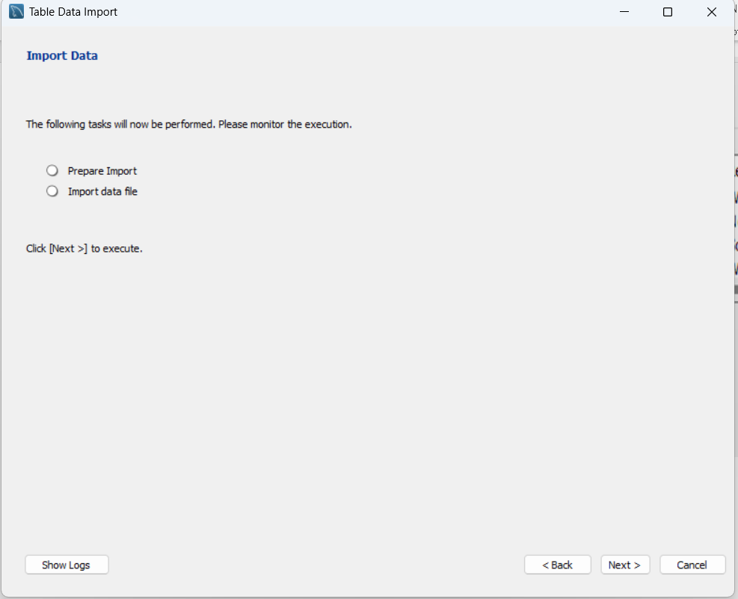

Click Next to start the Import Data
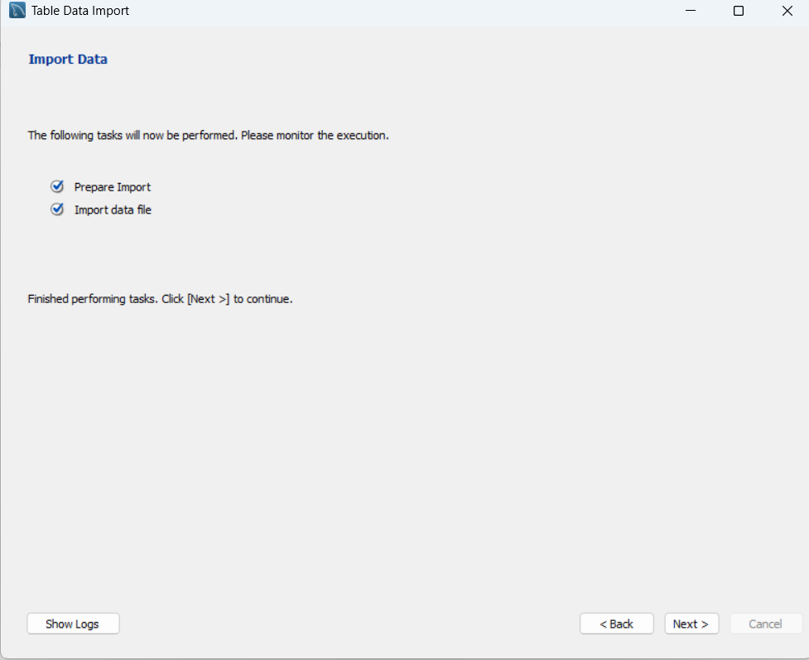

Click Next to show the results
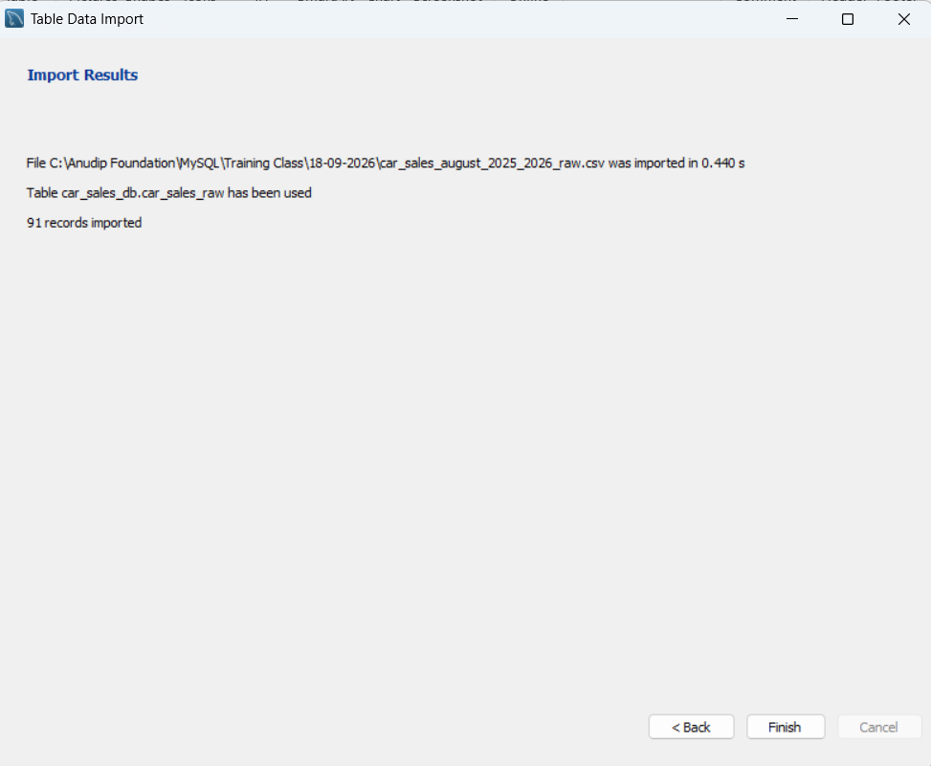
Click Finish
desc car_sales_raw;
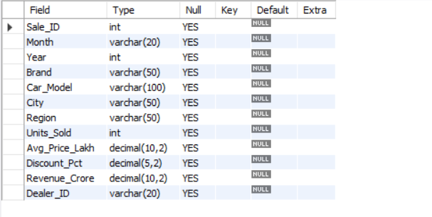

select * from car_sales_raw;
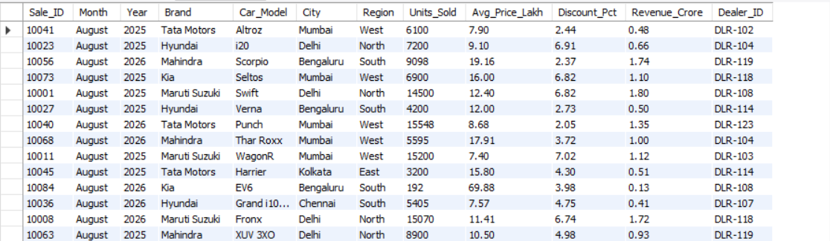
select count(*) from car_sales_raw;
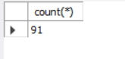
SELECT Sale_ID, COUNT(*) AS duplicate_count
FROM car_sales_raw
GROUP BY Sale_ID
HAVING COUNT(*) > 1;
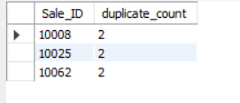
SELECT * FROM car_sales_raw
WHERE Sale_ID IN (
SELECT Sale_ID
FROM car_sales_raw
GROUP BY Sale_ID
HAVING COUNT(*) > 1
);
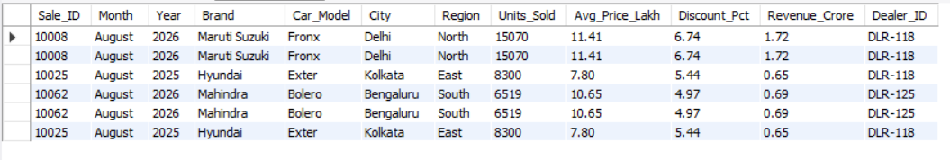

SELECT
SUM(Sale_ID IS NULL) AS missing_sale_id,
SUM(Month IS NULL OR TRIM(Month) = '') AS missing_month,
SUM(Brand IS NULL OR TRIM(Brand) = '') AS missing_brand,
SUM(Car_Model IS NULL OR TRIM(Car_Model) = '') AS missing_model,
SUM(City IS NULL OR TRIM(City) = '') AS missing_city,
SUM(Region IS NULL OR TRIM(Region) = '') AS missing_region,
SUM(Avg_Price_Lakh IS NULL) AS missing_price,
SUM(Discount_Pct IS NULL) AS missing_discount,
SUM(Revenue_Crore IS NULL) AS missing_revenue,
SUM(Dealer_ID IS NULL OR TRIM(Dealer_ID) = '') AS missing_dealer
FROM car_sales_raw;
UPDATE car_sales_raw
SET
Month = TRIM(Month),
Brand = TRIM(Brand),
Car_Model = TRIM(Car_Model),
City = TRIM(City),
Region = TRIM(Region),
Dealer_ID = TRIM(Dealer_ID);
SELECT DISTINCT Brand FROM car_sales_raw ORDER BY Brand;
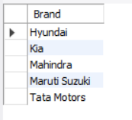

CREATE TABLE car_sales_clean AS
SELECT
Sale_ID,
TRIM(Month) AS Month,
Year,
TRIM(Brand) AS Brand,
TRIM(Car_Model) AS Car_Model,
TRIM(City) AS City,
TRIM(Region) AS Region,
Units_Sold,
Avg_Price_Lakh,
Discount_Pct,
Revenue_Crore,
TRIM(Dealer_ID) AS Dealer_ID
FROM car_sales_raw;
select * from car_sales_clean;
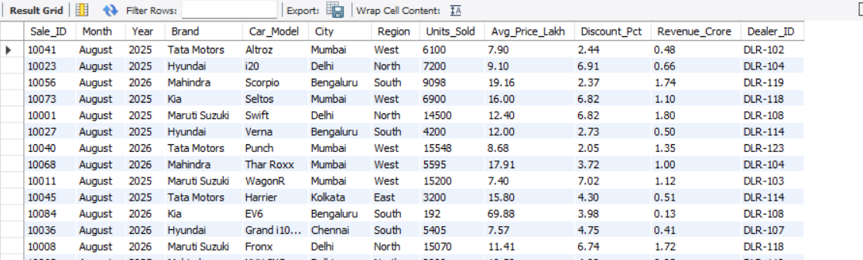

Click Export Icon to Save the CSV File
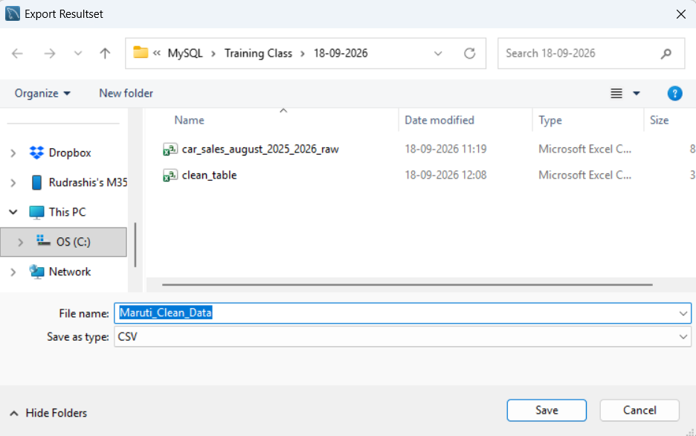
The name to save is “clean_car_table.csv”

